Year 7 Data Handling Lesson

Friday 12th November

Thomas Robinson

- Lesson Plan

Clevedon School - Lesson Plan
Date: 12/11/10 |  |  | Period: (Circle or Bold) |  |  | 1 | 2 | 3 |  | 4 | 5 |  | 6
Teacher: TR (MA) |  |  | Room: IT4 |  |  |  | Subject: ICT
Year: (Circle or Bold) | 7 | 8 | 9 | 10 |  |  | 11 |  | 12 |  |  | 13
Ability: (Circle or Bold) | Higher | Middle |  | Mixed |  |  |  |  | Lower
Number in Group: Boys Girls |  |  | Number of SEN: Boys Girls |  |  |  | Number of Gifted &/or Talented: Boys Girls
Tasks/Role of Support Staff:
N/A
Learning Outcome(s):
- Demonstrate data collection skills by using the Internet to find weather information and to store the information electronically.
Inclusion Strategies Able:  - Extension Tasks – Option to look for additional data types such as pressure, cloud, and wind speed.  - Supporting other students (Facilitating two before me) |  |  |  |  | Inclusion Less Able:  - Support from:  Peers - two before me  Teacher  Exemplar Work
BIG Picture:
Students are learning how to efficiently use data and information sources by taking environmental measurements and manipulating the results using ICT. This will support their work in Science lessons.
Clevedon Lesson Outline / Planned Learning (Knowledge, Understanding, Skills, Literacy/Numeracy/ICT):

STARTER:
Students will look at a website and identify what weather data is available from the website.

TASK INTRODUCTION:
Collect rainfall and temperature forecast information for the next 10 days using a website of their choice. They will then record the information that has been gathered using Microsoft Excel.

LEARNING DEVELOPMENT:
Students will learn how to setup tables within excel and how to gather data using the internet. They will demonstrate understanding of this by completing the main task and answering plenary questions.

MID LESSON LEARNING CHECK:
Some good examples of work will be exhibited to the rest of the class, they then will be asked about their progress and their expectations of progress for the rest of the lesson.

LEARNING REVIEW
Name some search engines?
Name some different weather websites?
What are the different measurements associated with weather?
Can you name a top free phone app for the weather?
Assessment For Learning:
Mid-lesson survey and plenary questions and commenting on each others work.
Next Lesson:
Use the data to create a neatly formatted table and to analyse the weeks weather using: SUM / AVERAGE / MAX / MIN.

2. Evaluation

There were lots of things that went well in these lessons; the observer commented that my ability to understand and relate the students is an area of strength and that the classroom has a calm atmosphere when I am teaching. Students did make significant progress during the lesson, however some students didn’t achieve their full potential.

I always met groups at the door, checking uniform and giving instructions about seating arrangements and expectations on entry to the room (Q2) I made the work topical through the plenary section of the lesson by asking: “Can you name a top free phone app for the weather?” and then showing a slide with screenshots of the app and getting them to identify the different pieces of information.

Before this lesson I had been working to improve classroom entries and exits, completing uniform checks at both points, dismissing groups a section at a time, building the dismissal into the plenary work etc. I was also beginning to become more aware when it came to behavior within the classroom - insisting on silence when I was speaking, checking monitors were switched off when requested and perfect uniform.

Things that need improvement; My communication when addressing a whole class (Q4) is an area of weakness, I need to project my voice much more effectively so that instructions are loud and clear, linked to this I need to be clearer about the lesson outcomes and explaining them in a way that the students will understand. It is also important that I explain tasks and theories in a way that is going to excite students about the work they are going to complete.

I need to be more mindful of how students are going to progress through the work between lessons and whether homework needs to be set to facilitate that. Checking resources before the lesson, there was an instance in the first lesson where the site that they were using for the task had been filtered.

- Observers Form
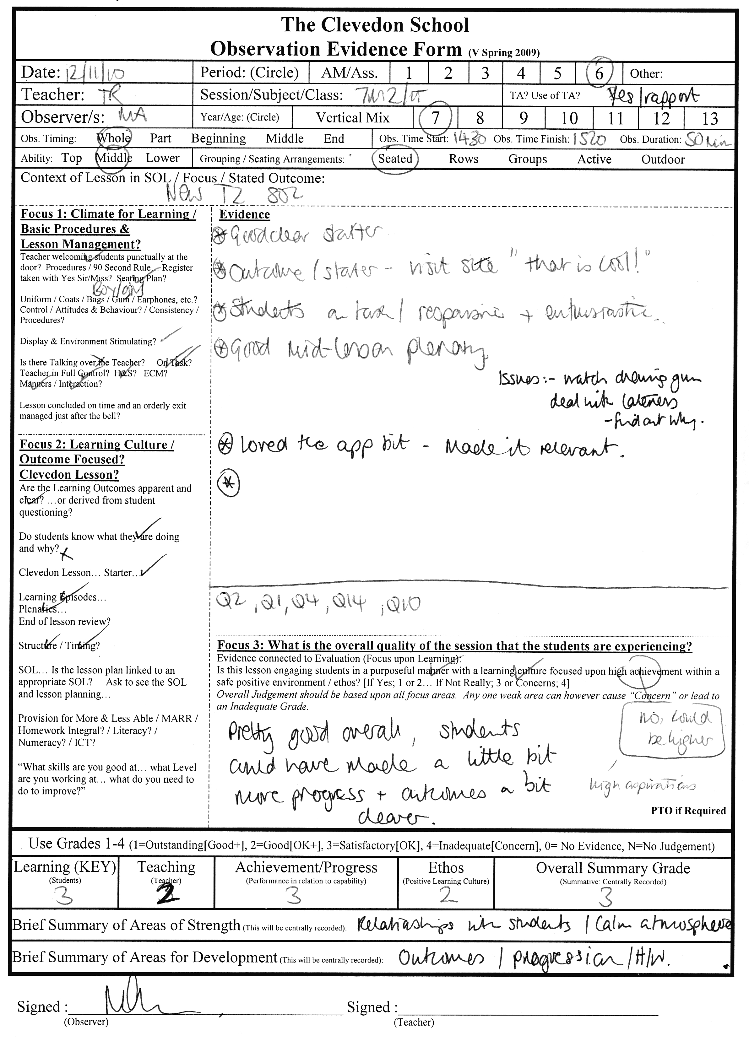
- PowerPoint Resource

